**3. MODELING AND SIMULATION:**

As shown in the section 2 digital filters consist of a lot of constant multipliers. Multiplying two numbers uses a lot of hardware resources. The central problem then becomes substituting the full multipliers by an optimized sequence of shift, additions and subtractions. The whole filter is shown in figure 3.1 .The frequency response of the filter is shown in figure 3.2 and the filters coefficients and their 2’s complement representation and CSD representation are shown in table 3.1 and table 3.2 respectively.

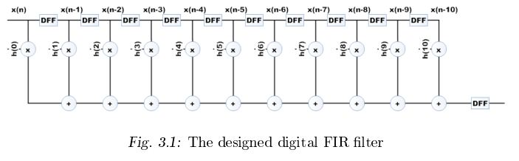DFF: Delay Flip Flop

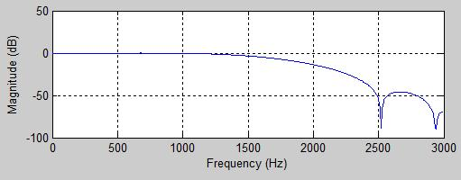

Fig. 3.2: Frequency response of designed filter.



Institute of Technology,

Banaras Hindu University

Department Of Electronics Engineering

**Canonical Signed Digit (CSD) Based Low Power FIR Filter Design**

Submitted By:

Mukul Sharma Gaurav Verma Ajit Singh Songara

08105EN063 08105EN064 08105EN069

Under Guidance:

Prof. R. Dwivedi